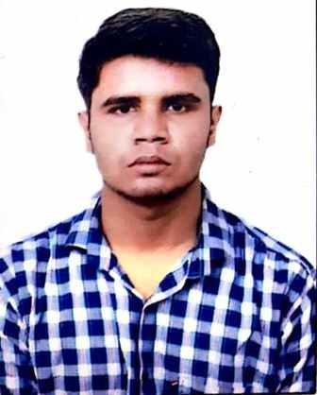
Harshak Saini
Developer
harshaksaini@gmail.com

9716791000

Gurgaon, India

Secure a responsible career opportunity to fully utilize my training and skills,while making a signiﬁcant contribution to the success of the company.

EDUCATION

Computer Science
JAVA
Python

Dronacharya College of Engineering
2021 - Present, Gurgaon
Courses
B.TECH

12th

St. Michael's Sr. Sec. School
2021, Gurgaon
Courses
93.0

SKILLS
C
C++

STRENGTHS
Hard Working

Good Leadership Qualities A continuous learner

10th
St. Michael's Sr. Sec. School
2019, Gurgaon
Courses
91.2

LANGUAGES
English
Proﬁciency

Hindi
Full Professional Proﬁciency

INTERESTS
WORKSHOP AND TECHNICAL EVENTS
Running
Sports

Particiapted in internal Smart India Hackothon held at
Dronacharya College of Enginnering on 12th March 2022. CERTIFICATE AND COURSE

Made project on Hospital Management System using
python-mysql interferce. Certificate of completion of C training offered by
Spoken Tutorial Project , IIT BOMBAY.
Attended two days Web Development Workshop at
Dronacharya College of Enginnering in December 2021. C For Everyone: Programming fundamentals
an online non credit course authorized by
Attended NATIONAL INTELLECTUAL PROPERTY University of California, Santa Cruz and offered
AWARENESS MISSION on April 29,2022 Jointly through courser.
Organized by Intellectual Property Office and MoE's
Innovation Cell, India. C For Everyone: Structured Programming
an online non credit course authorized by
University of California, Santa Cruz and offered
through courser.

